

INSTALLATION AND OPERATION MANUAL

FA-60EC,FA-120EC, FA-240EC,FA-350EC,FA-500EC
Mixer Amplifiers with Mp3/FM/BT

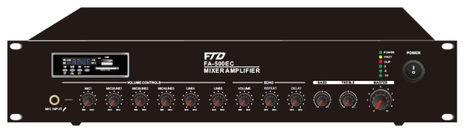




Caution: Please read this manual carefully before operating Damage caused by misuse is not covered by the warranty

SAFTY WARNINGS!
1. Read and keep these instructions.
2. Heed all warnings and follow all instructions.
3. Do not use this apparatus near water.
4. Do not block any ventilation openings. Install in accordance with the manufacturer’s instructions.
5. Do not install near any heat sources such as radiators, heat registers, stoves, or other apparatus that produce heat.
6. Do not defeat the safety purpose of the polarized or grounding-type plug. A polarized plug has two blades with one wider than the other. A grounding type plug has two blades and a third grounding prong. The wide blade or the third prong is provided for your safety. If the provided plug does not fit into your outlet, consult an electrician for replacement of the obsolete outlet.
7. Protect the power cord from being walked on or pinched particularly at plugs, convenience receptacles, and the point where they exit from the apparatus.
8. Only use attachments/accessories specified by the manufacturer.
9. Use only with the cart, stand, tripod, bracket, or table specified by the manufacturer, or sold with the apparatus. When a cart is used, use caution when moving the cart/apparatus combination to avoid injury from tip-over.
10. Unplug this apparatus during lightning storms or when unused for long periods of time.
11. Refer all servicing to qualified service personnel. Servicing is required when the apparatus has been damaged in any way, such as power-supply cord or plug is damaged, liquid has been spilled or objects have fallen into the apparatus, the apparatus has been exposed to rain or moisture, does not operate normally, or has been dropped.
12. This appliance shall not be exposed to dripping or splashing water and that no object filled with liquid such as vases shall be placed on the apparatus.
13. Plug this apparatus to the proper wall outlet and make the plug to be disconnected readily operable.
14. Main plug is used as disconnected device and it should remain readily operable during intended use. In order to disconnect the apparatus from the mains completely, the mains plug should be disconnected from the mains socket outlet completely.
15. WARNING: To reduce the risk of fire or electric shock, do not expose this apparatus to rain or moisture.
16. An appliance with a protective earth terminal should be connected to a mains outlet with a protective earth connection.

WARNING!
TO PREVENT FIRE OR SHOCK HAZARD, DO NOT USE THE PLUG WITH
AN EXTENSION CORD, RECEPTACLE OR OTHER OUTLET UNLESS THE BLADES
CAN BE FULLY INSERTED TO PREVENT BLADE EXPOSURE.
TO REDUCE THE RISK OF FIRE OR ELECTRIC SHOCK, DO NOT EXPOSE
THIS APPLIANCE TO RAIN OR MOISTURE.
TO PREVENT ELECTRICAL SHOC
K, MATCH WIDE BLADE PLUG TO WIDE SLOT, FULLY INSERT.


INTRODUCTIONS

Description
The PA Mixer Amplifier with MP3, FM tuner & blue tooth, its rated power output from 60W, 120W to 500W, it is ideal for school, super market, bank, hotel BGM and speech use. It is all in one solution with two sources, pre amplifier and mixer power amplifier into one unit, which is economy but of high reliable performance.

It integrates 2 audio sources into a mixer amplifier, plus Mic1 and Mic/Line input 2-3 all in XLR, two line inputs, one line output. EMC input with highest priority. One USB and one SD slots on front provide easy access and operation for installer and end-user.

The amplifier is designed with complete protection of overload, short circuit and high temp to avoid any damage.
These amplifiers are suitable for applications in bank, mosque, school, hotel, restaurant, theme centers and shopping center.

Features
l 19” rack size public address amplifier
l Built-in 100V/70V transformer technology
l Amplifier with Mp3 player, FM radio & blue tooth, Echo
l Rate power output at 60W, 120W , 240W , 350W to 500W
l Speaker output of 100V or 70V & 4Ohms-8 Ohms-16 Ohms
l Mp3 player with USB/SD input on front panel, IR remote control for Mp3 player, FM radio and blue tooth
l LED indicators for power, clip, protect and signal
l Mic1-3 and line 1-2. Mic1 of balanced XLR input with phantom power on rear panel. Mic2-3 microphone or line switchable unbalanced 6.3mm phone jack input. Line 1-2 input of RCA input and one RCA line output. Volume control for Mic1-3, line1-2, Mp3/FM, bass/treble and master, ECHO
l With short-circuit, clip, overload and high temp protection
l AC220V or 115V & 24V DC both operation system

FRONT PANEL
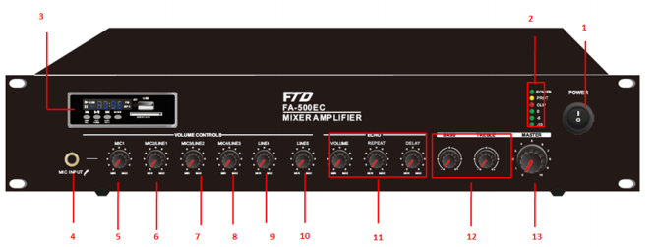

1. AC power switch.
2. LED Indicator.
3. Mp3/FM/Blue tooth media player module
4. MIC1 input
5. Mic1 Attenuator.
6. Mic2/Line Input 1 Attenuator.
7. Mic3/Line Input 2 Attenuator.

8. MIC4/Line Input 3 Attenuator.
9. Line Input 5 Attenuator.
10. Line Input 5 Attenuator
11. Echo function
12. Bass and Treble
13. Master Volume Control

REAR PANEL
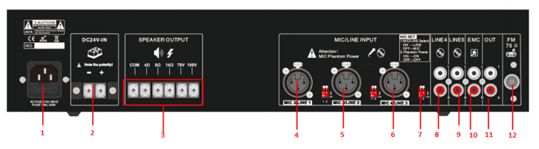

1. AC Power Socket.
2. 24V DC Battery Input.
3. Speaker output 100V/70V/4-16ohms.
4. Input 2 Mic/Line1 input
5. Input 3 Mic/Line2 input.
6. Input 4 Mic/Line3 input.
7. Dipswitch for MIC/LINE selector, phantom power and

microphone priority.
8. Line 4 Input
9. Line 5 Input.
10. EMC Input.
11. Line Output.
12. FM Antenna.

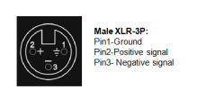

AMPLIFIER OPERATION GUIDANCE

100V Line System
For 100V line systems, connect the amplifier to the first speaker in the system using double-insulated speaker wire which has adequate current rating to handle the total output of the amplifier.
Connect the “100V” output terminal to the positive (+) connection of the speaker and “COM” output to the negative (-) connection of the speaker. Connect further speakers in parallel to the first speaker with all positive terminals and connected together and all negative terminals connected together as shown below.
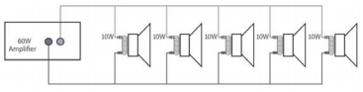
A 100V line speaker system can comprise of many speakers connected together. The determining factor for how many speakers can be used on a single amplifier is the power rating. For most purposes, it is advised to connect as many speakers as needed with a combined wattage of no more than 90% of the amplifier’s output power rating.
The terminals of a 100V speaker are connected to a transformer and in some cases, this transformer may be “tapped” for different power ratings. These tappings can be used to adjust the wattage (and output volume) of each speaker in the system to help achieve the ideal total power of the system for the amplifier.
The mixer amplifier is featured of 6 speaker zone outputs, either one of six zone or total six zone power loading shall be equivalent or no higher than the rated power of the amplifier.

Speaker Terminals
These terminals are offering 3 low voltage outputs 4Ω, 8Ω, 16Ω depending on your speaker combination. A 70V/100V commercial output is also available. Please note that one wire only should be connected to COM screw and one wire to the selected impedance or voltage. Multiple combinations cannot be done at the output level. Four different types of connections are provided. The low impedance section: 4Ω, 8Ω, 16Ω is designed for a small amount of speakers to be connected to your amplifier. The 70V/100V section is especially designed for a multiple speaker distribution. When using the 70V/100V output, speakers have to be equipped with 70V/100V transformer. The maximum amount of speakers to be placed on your distribution line is in relation to the power allocated to each speaker. The total wattage set on the secondary side of the transformers on your speaker line must not exceed the maximum RMS output power: 30W, 60W or 120W. Failure to respect this may cause permanent damage to the amplifier.

Speaker Connections
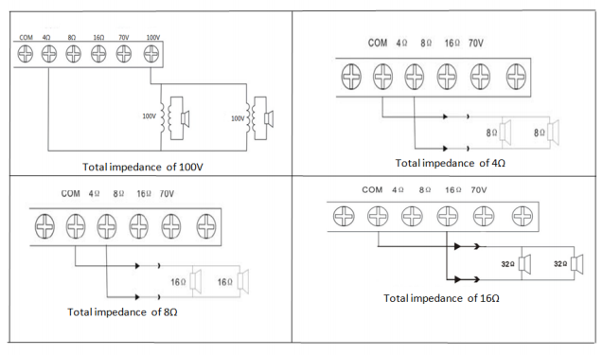

Operation Steps
l When all connections to the amplifier are made, turn all rotary controls down and switch on the power and a power “ON” LED will illuminate. Turn BASS and TREBLE controls to the 12 o’clock position (pointing straight up) and turn MASTER rotary control up part way for testing.
l Ensure a signal is being fed to one of the line inputs 1, 2, 3, 4 or 5 and gradually increase the volume control for that channel until the output is heard through the speakers. Turn up the MASTER to the maximum required volume level and reduce the channel volume control if necessary.
l Note: The initial test can be made using the built-in USB/SD/FM audio player. The output of the amplifier is represented on the level meter LEDs and care should be taken that the Red “0” LED is only lit momentarily during use. Anything longer than a short flash of this LED may be indicating distortion or clipping of the output signal and the MASTER should be turned down.
l If a microphone is connected to MIC1 input, make sure it is switched on and if it requires phantom power, make sure this feature is enabled. Gradually increase its volume control whilst speaking into the microphone until the required volume level is reached. The microphone should not be able to “hear” the speakers, which can cause feedback (squealing or howling noise).
l If the VOX feature is enabled, audio playback through channels 2-5 will be reduced in volume automatically when speaking into MIC 1, use its attenuator to increase or decrease the mute level.
l In addition to channel and MASTER volume controls, there are BASS and TREBLE EQ controls to adjust the tone of the overall output. At the 12 o’clock position, these controls are applying no effect to the signal (no boost or cut). Moving the BASS control clockwise boosts the low frequencies in the audio, whilst moving it anticlockwise will cut these low frequencies. Likewise, moving the TREBLE control clockwise boosts the high frequencies in the audio, whilst moving it anticlockwise will cut these high frequencies. Adjust these EQ controls to suit the type of audio signal or compensate for the room acoustics.

USB/SD Playback
Push a USB pen drive into the USB port and/or an SD card into the SD card input.
Press the USB/SD button to ensure that the player is set to play from the required memory device. Press the PLAY/PAUSE button to play the current track and press again to pause as needed.

FM Tuner
Press the FM select button to switch to the FM tuner function. Use the Previous or Next buttons to select a stored channel.

Tuning and storing stations
Use the Forward/Reverse seek buttons to manually tune the frequency in steps of 0.05MHz
Alternatively, press and hold the Forward/Reverse seek buttons to auto search for available stations. Upon finding a station, the auto search will stop, giving the option to store this station.
At this point, pressing the PLAY/PAUSE button will flash a “00” channel number in the display. Use the Previous/Next buttons to select an appropriate channel memory.
Press PLAY/PAUSE again to confirm and store the station into the selected channel memory. Auto search can be stopped at any time by pressing the Forward/Reverse seek buttons.

EMC input
If have any audio signal input from EMC input, it will cut the BGM and play EMC audio in highest proirity

CONNECTION DIAGRAMS
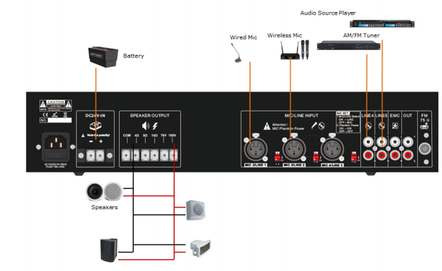

SPECIFICATION SHEET

Model | FA-60EC | FA-120EC | FA-240EC | FA-350EC | FA-500EC
Description | PA Amplifier with USB/SD & FM & Blue Tooth
Rated Power Output | 60W | 120W | 240W | 350W | 500W
Speaker Outputs | 100V or 70V & 4Ohms-8 Ohms-16 Ohms
Connector | Mic1 input by balanced XLR with phantom power  Input2-3 inputs Mic/Line switchable unbalanced 6.3mm phone jack Line1-2 inputs by RCA; Line output by RCA
Attenuation | Microphone1-3, line1-2 and Mp3/FM, bass/treble and master
Input | MIC1-3: 5-8mV, 600Ω; Line, 150-470mV, 10KΩ, unbalanced RCA
Line Out | 0.775(0dBV)
Frequency Response | 60Hz-15kHz(±3dB)
S/N Ratio | Line ≥ 85dB, Mic≥ 72dB
THD | Less than 0.5%
Protection | short-circuit, clip, overload and high temp protection
Power Consumption | 60W | 120W | 240W | 350W | 500W
Power Supply | AC220V or 115V & 24V DC /50-60Hz
Dimension | 484(W)×320(D)×88(H)mm
Weight | 9.5kg | 10.5kg | 13.5kg | 14.5kg | 15.5kg

SERVICE
Ensure the problem is not related to operator error, or system devices that are external to this unit. Information provided in the troubleshooting portion of this manual may help with this process. Once it is certain that the problem is related to the product contact your warranty provider as described in the warranty section of this manual.

WARRANTY
Warranty terms of global three years. While the term and warranty may vary by country and may not be the same for all products. Terms and conditions of warranty for a given product may be determined first by locating the appropriate country which the product was purchased in, then by locating the product type.

Specifications may change without pre-notice.

